# 1. COMPUTER HARDWARE

**WHAT IS COMPUTER?**

**\*** A computer is an electronic device or in general, it’s a machine. A machine is a tool that makes people’s lives easy. Many machines do it tangibly. But a computer makes it in an intangible way. This requires a computer to come up with four tasks. These tasks are **receiving input, storing, processing and giving output**.

* Computers have two main parts. These are **hardware and software**. Hardware and software work together.

**COMPUTER HARDWARE**

* Software, with its set of instructions, controls hardware. Hardware, with its components like screen, printer, microphone, and speaker, obeys the instructions. If we look at the hardware, we will see some major parts like **Central Processing Unit (CPU), Memory (Main Memory, Random Access Memory or Primary Memory... All are the same), Storage Devices, Input Devices (like mouse and keyboard), Output Devices (like monitors and printers), Communication Devices (like modem or Network Interface Card (NIC))**. All of these components are connected via **Bus System**. Bus System is a kind of complex road system which delivers **data and power** among all of the systems inside the computers.

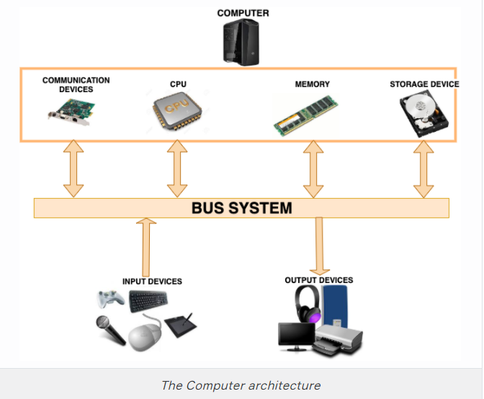

* Hardware" refers to the physical parts of the computer, and "software" refers to the code that runs on the computer.

* Modern computers use tiny electronic components that can be etched onto the surface of a **silicon chip**. Chips are packaged in plastic, with little metal legs. Tiny wires connect the chip to the outside**. The most common electronic component is the transistor which regulates current or voltage flow and acts as a switch or gate for electronic signals.** The transistor is a "solid-state" device, meaning it has no moving parts. It is a basic building block used to construct more complex electronic components. For example, chips can contain billions of transistors.

## Hardware Components

### Central Processing Unit

* The Central Processing Unit (CPU) is the **brain of the computer. It reads the data from the memory, processes and writes the output back in the memory**. It controls all the software and hardware properties. The CPU has two parts to accomplish these tasks. One is **Arithmetic/Logic Unit** and the other one is the **Control Unit**. Control Unit controls the actions of all other components, whereas the Arithmetic/Logic Unit makes the logical and arithmetic computations. The arithmetic computations consist of **addition, subtraction, multiplication and division**. And the logical computations consist of **comparisons**.

* Physically, a CPU is a collection of millions of transistors which are like tiny electric switches. For example, Intel i7 processor would have roughly **2.1 billion transistors**.

* A computer’s calculation power stems from this ability. The computer manufacturers try to increase the number of CPUs to enhance this ability.

### Memory (RAM)

* Memory is the worksheet of a computer. Before it’s processed by the CPU, the data should be written to that worksheet. Memory also can be called Random Access Memory (RAM). RAM store data **temporarily**, data is lost when the computer power is turned off and it is called "random access" because any storage location can be accessed directly.

### Storage Devices

* In contrast to memory, storage devices don’t let the data be wiped out after the power is turned off. They can **store the data permanently**. The storage devices have different forms. In general, they are divided into three. These are **Magnetic Disk Drives, Optical Disk Drives, Universal Serial Bus flash drives**.

* While Optical Storage media are cheap and removable, they have even slower latencies then magnetic storage and lower capacity as well. Another type of long term storage is Solid State drives like Solid State Drives (SSD). These have no moving parts, they store data by electrical charges. The newest and the fastest memory type of long term storage are Non Volatile Memory Express Solid State Drives(NvME SSD). NvME perform many of the input/output operations in parallel

* Comparing with the memory, a storage device can have **much more amount of space** to store but the problem in here is the time to read and write. The **memory is much faster than the storage device**.

### Input and Output Devices

Input and output devices are the interfaces to communicate with the outside world. Keyboard and mouse are widely used for input, while the monitor and printer are used for output.

**Keyboard**

The keyboard is the tool for entering input to the computer. This input could be a character, a number or up, down, right, left value. Some of the keys don’t cause an input but have the ability to change the value of another key when pressed together. These keys are called **modifier keys** (such as Shift, Alt, Ctrl and Cmd). There is also a Function Key. Function Key operates in a different way defined by the software that is used at that moment.

**Mouse**

The mouse is a graphical pointing device to click on a clickable object and start operation.

**Monitor**

The monitor displays text and graphical information. It’s a **human-machine interface** and the **main output area** for the operations in the computer. The screen **resolution** and the **dot pitch** are two features for a qualified monitor. The **resolution shows the number of pixels** in the horizontal and vertical axis of the screen.

A pixel is the smallest colorful part of a picture. The higher the resolution, the better the image quality is.

### Communication Devices

* Computers can talk to each other via communication devices like **fiber optic cables, digital subscriber line (DSL), a cable modem, network interface card (NIC), a wireless adapter and from satellites**.

* DSL uses the phone lines to connect to the internet, A cable modem uses **a separate cable for connection** and it is a faster communication type comparing to DSL.

* Fiber Optic Cables are special cables, they are like glass and data transferred as fast as laser light on glass. It's very fast for data transfer compared with DSL or cable modem. Fiber Optic cables are widely used for communication.

* A **router** is a networking device that forwards data packets between computer networks.

* A network interface card **connects a computer to a local network** (Local Area Network (LAN) ). LANs are used for connecting computers in a limited range.

* A communication satellite is an artificial satellite stationed in space for the purpose of telecommunications.

# 2. OPERATING SYSTEMS

## Introduction

Operating System is the main **program** that runs on a computer. It communicates with the hardware. It’s the **bridge** between the hardware and all other software programs. Widely used operating systems on computers are Windows, MacOS, Ubuntu but on mobile phones Android, iOS. Mobile phones and computers have different operating systems because their resources, operations, inputs and outputs are different.

The operating system **controls and monitors the system activities, allocates and assigns system resources and schedules the operations**. Such as:

* Detecting an input from the keyboard,
* Sending output to the monitor or tracking [files](https://lms.clarusway.com/mod/lesson/view.php?id=1052) or folders in the storage area,
* Controlling peripheral devices such as disk drives and printers,
* Running different programs at the same time and not letting interfere with each other,
* Checking users if they are authorized or not are some examples of controlling and monitoring system activities.

Operating System allocates and assigns the resources like **memory space, disks, input/output devices and CPU time** to the application programs. At any time during runtime, there can be conflicting requests for a resource. Operating System has to deal with all these requests, define a priority list and return either a positive or a negative response. While using system resources Operating System manage them avoiding **deadlock**. Deadlock is a situation when two or more processes wait for each other to finish and none of them ever finish.

# 3. DATA AND STORAGE

ASCII (American Standard Code for Information Interchange) is an encoding representing each typed character by a number and each number is stored in one byte (so the number is in 0..255).

**Typing and Bytes**: Each letter is stored in a byte, as below. 1000 typed letters take up 1000 bytes.

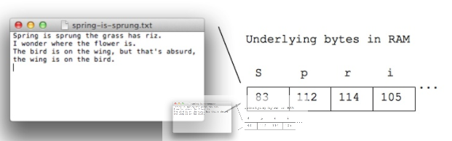

**Unicode** is a universal character encoding standard. It defines the way individual characters are represented in text [files](https://lms.clarusway.com/mod/lesson/view.php?id=1052), web pages, and other types of documents. It is different from ASCII, Unicode was designed to support characters from all languages around the world, mathematical character emojis etc. The standard ASCII character set only supports 128 characters, while Unicode can support roughly 1,000,000 characters. While ASCII only uses one byte to represent each character, Unicode supports up to 4 bytes for each character.

Individual characters hold one byte on computer storage. But computers are also good at calculating and playing numbers. We call number holders as **integers**. Integers are typically stored with either 4 or 8 bytes.

4 bytes can store numbers between -2147483648 and 2147483647  
8 bytes can store numbers between -9223372036854775808 and 9223372036854775807

Kilo/Mega/Gigabytes

**Kilobyte** equals to about one thousand bytes (1024 bytes). A page of ordinary Roman alphabetic text takes about 2 kilobytes to store (about one byte per letter). A typical short email would also take up just 1 or 2 kilobytes. While you were sending a message from internet text messages are sent faster than audio or image. So text is compact, requiring few bytes compared to images or sound or video.

**Megabyte** equals to about one million bytes (about 1000 KB). A high-quality digital picture is about 2-5 megabytes and mp3 audio is about 1 megabyte per minute.

**Gigabyte** is about a billion bytes (about 1000 MB). Gigabyte is a common metric for [hardware components](https://lms.clarusway.com/mod/lesson/view.php?id=44). For example, while you are looking for computer 4 GB RAM and 256 GB of persistent storage is ordinary computer properties.

**Terabyte** is about 1000 gigabytes or roughly 1 trillion bytes. You can buy 4 TB hard drives today, so we are beginning the time when this term comes into common use.

There is one term too heard a lot. It is **Gigahertz**. Gigahertz is not about bytes. It is about speed. One gigahertz is 1 billion pulses per second (a megahertz is a million pulses per second). Gigahertz is a measure of speed, very roughly the rate that at a CPU can do its simplest operation per second. Gigahertz does not precisely tell you how quickly a CPU gets work done, but it is roughly correlated.

Math Examples

In this section, we will convert [bits and bytes](https://lms.clarusway.com/mod/lesson/view.php?id=886).

Question: 8,000,000 bytes is about how many MB?  
Answer: 8 MB (1,000,000 Bytes = 1 MB )

Question: 25,000 KB is about how many MB?  
Answer: 25 MB (1000KB = 1MB)

Question: 100 KB is about how many MB?  
Answer: 0.1 MB

Question: How many GB is 16,000,000,000 bytes?  
Answer: 16 GB

Question: Say you have many 8 MB JPEG images. How many fit on a 32 GB flash drive?  
(convert everything to MB) Answer: 32 GB is 32,000 MB 32,000 / 8 = 4,000

## Software and Programming Languages

### Software

Computers do not understand human language. They do understand 1s and 0s, [bits and bytes](https://lms.clarusway.com/mod/lesson/view.php?id=886). The computer programs fill this gap. A computer program, also called software, is a **set of commands** that a computer should execute one by one.

Software is a set of instructions, data or programs used to operate computers and execute specific tasks. Opposite of hardware, which describes the physical aspects of a computer, the software is a generic term used to refer to applications, scripts, and programs that run on a device. The software can be thought of as the variable part of a computer and hardware the invariable part.

# 4. WHAT IS SOFTWARE?

# 5. [HOW DOES INTERNET WORK?](https://lms.clarusway.com/course/view.php?id=5&section=5)

What is a Web Browser?

Introduction

A browser is a software designed to find and display content on the World Wide Web. This content might be **a web page, a pdf document, a picture, a video or any other content**. The richest content is a web page. A web page is usually an HTML document which stands for **Hyper Text Markup Language**. Web browsers are also able to run **CSS (Cascading Style Sheet) and Javascript code**. CSS styles the HTML pages to make them look beautiful. And Javascript gives the page the ability to interact with users, show dynamic content and listen to specific **events**.

Events are fired inside the browser window and tend to be attached to a specific item that resides in it (this might be a single element, set of elements, the HTML document loaded in the current tab or the entire browser window). Different types of events occur on the browser. For example:

* Clicking or hovering the cursor over a button, link, picture, etc.
* Pressing a key.
* Resizing, minimizing, maximizing or closing the browser window.
* Loading a web page.
* Submitting a form.
* Playing, pausing a video.

Browsers have common features like address bar, back and forward buttons, bookmarking options, buttons for refreshing the page and stopping the request and home button to direct the user to the home page.

## Web Browser Structure

### Introduction

Web browsers have seven high level components. These are **User Interface, Browser Engine, Rendering Engine, Networking, Javascript Interpreter, UI Backend and Data Storage**.

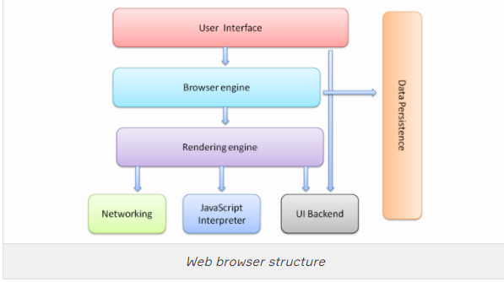

* ***User Interface*** :The user interface is where the users interact with the browser.
* ***Browser Engine*** :The browser engine is the bridge between the user interface and the rendering engine. It relays the necessary information to the rendering engine for performing a render.
* ***Rendering Engine*** :The rendering engine is responsible for rendering the requested content and displaying it on the screen. It may be either an HTML, a CSS or a JS content.
* ***Networking*** :The networking component uses the URL given by the user and retrieves the page via a protocol called HTTP or a file via FTP protocol.
* ***Javascript Interpreter*** :The Javascript interpreter, as the name suggests, interprets and execute the Javascript code of the web page. Then the results are sent to the rendering engine for displaying.
* ***UI Backend*** :The UI Backend is responsible for drawing basic widgets like combo boxes and windows. It uses operating system user interface methods.
* ***Data Storage*** :The data storage is persistence layer. The browser may need a small storage area to store, process or show data. So there are some mechanisms for storing like localStorage, sessionStorage, IndexedDB, WebSQL and FileSystem.

## What is HTTP?

### Introduction

**Hypertext Transfer Protocol (HTTP)** is an application layer designed within the framework of internet protocol suite. It is used for transferring **text, image, sound, video or any other type of multimedia**[**files**](https://lms.clarusway.com/mod/lesson/view.php?id=1052). When a web browser tries to reach a specific web address, it wants to get in touch with the computer holding all the necessary [files](https://lms.clarusway.com/mod/lesson/view.php?id=1052). So basically the client web browser sends an **http request** to get an HTML content or any specific data staying inside the server computer. When the server computer gets the request, it returns an **http response** containing the information requested.

The statement written in the address bar is called **Uniform Resource Locator (URL)**. URLs are the keys to specify a computer and its IP address in the network. The browser should use this key to find out the IP address of a particular computer. The system that is responsible to hold the values of these keys is [**Domain Name System (DNS)**](https://lms.clarusway.com/mod/lesson/view.php?id=943) [servers](https://lms.clarusway.com/mod/lesson/view.php?id=1015). If the DNS server knows the address, it answers. Otherwise, the DNS server starts to ask other DNS [servers](https://lms.clarusway.com/mod/lesson/view.php?id=1015) and fetches the information at the end. Therefore DNS gives it back to the browser and the browser can find the way to the correct destination using HTTP and other related protocols.

| **https://docs.google.com/uc?id=1eu-7nSL7a1q2XFiEYcUUtg8BLd5hmqey** |
| --- |
| Client and server model |

What is HTTP?

HTTP Request and Response

As mentioned before, HTTP (Hypertext Transfer Protocol) is a request-response protocol. A client on one side (web browser) asks or requests something (a resource located on the server) from a server (a computer responsible to respond to that request) and the server on the other side sends a response to that client. But before this request and response activities, a connection should be established. When we open our browser and write down the URL (Uniform Resource Locator), we are making the first step to connect to the resource. The URL is the address of that resource. It could be a website or a web service, a pdf or anything similar. If we pull apart the URL, we will see the structure like the one below.

URL = http: // host : port / path ? query

The host is the computer where the resource is stored. The host computers are given a human readable alias and this alias defines the IP address of the hosting computer in the URL. The port is the port number of the hosting computer and the path is the address where the resource file is located in the hosting computer. The query parameter is the value we give to the resource file while we try to establish the connection.

| **https://docs.google.com/uc?id=1mGrnn_dLCJ4IWme3lPPClWEfFa-6kFvM** |
| --- |
| *Request Message* |

If the URL starts with **HTTP** and there is no port value, the default port number is 80. If it starts with **https**, then the default port number is 443. The **path** and the **query** characters are optional. When the connection is established, the medium is available for transferring the request. But what is this request? A request is a text message and it has 4 parts which are request line, headers (optional), a blank line and a message body (optional).

| **https://docs.google.com/uc?id=1BAF_bekv5JkULW_uY5_CAZ2NHN9Hzzsr** |
| --- |
| *Request Message Example* |

The server responds to that request with an HTTP response message. The structure of the response message is similar to the request message. The one thing changed is the status line in place of the request line. A status line consists of the protocol version followed by a numeric status code and its associated meaning. Status code element is a 3-digit integer where the first digit of the status code defines the category of response. There are 5 categories. These categories are in its general state are expressed below.

* 1xx -> Informational
* 2xx -> Success
* 3xx -> Redirection
* 4xx -> Client Error
* 5xx -> Server Error

| **https://docs.google.com/uc?id=1MJO-DS1mavA1ECFKX2vvZ2QOiyfILSZf** |
| --- |

## What is HTTP?

### Certificates and HTTPS

**SSL** stands for Secure Sockets Layer and, in short, it's the standard technology for keeping an internet connection secure and safeguarding any sensitive data that is being sent between two systems, preventing criminals from reading and modifying any information transferred, including potential personal details. The two systems can be a server and a client (for example, a shopping website and browser) or server to server (for example, an application with personal identifiable information or with payroll information).

**TLS** (Transport Layer Security) is just an updated, more secure, version of SSL. We still refer to our security certificates as SSL because it is a more commonly used term.

**HTTPS** (Hyper Text Transfer Protocol Secure) appears in the URL when a website is secured by an SSL certificate. The details of the certificate, including the issuing authority and the corporate name of the website owner, can be viewed by clicking on the lock symbol on the browser bar.

